Evaporation & Leak Source Tests


By following this simple test procedure, which can easily be conducted by the pool owner you can get a fairly accurate idea whether you pool is actually leaking or not. By completing an extension of a series of 12 hr pump off/on tests from all pipe networks, the results can help ascertain where the leak source is occurring. These tests will help reduce the time required in locating the leak also saving the pool owner considerable expense.

EVAPORATION TEST
This is the first test which will confirm that the pool is in fact leaking. The test should be conducted over a 12 hr period with all equipment turned off. For best results the test should be conducted over night as there will be less evaporation therefore any leak in the pool will be more evident.
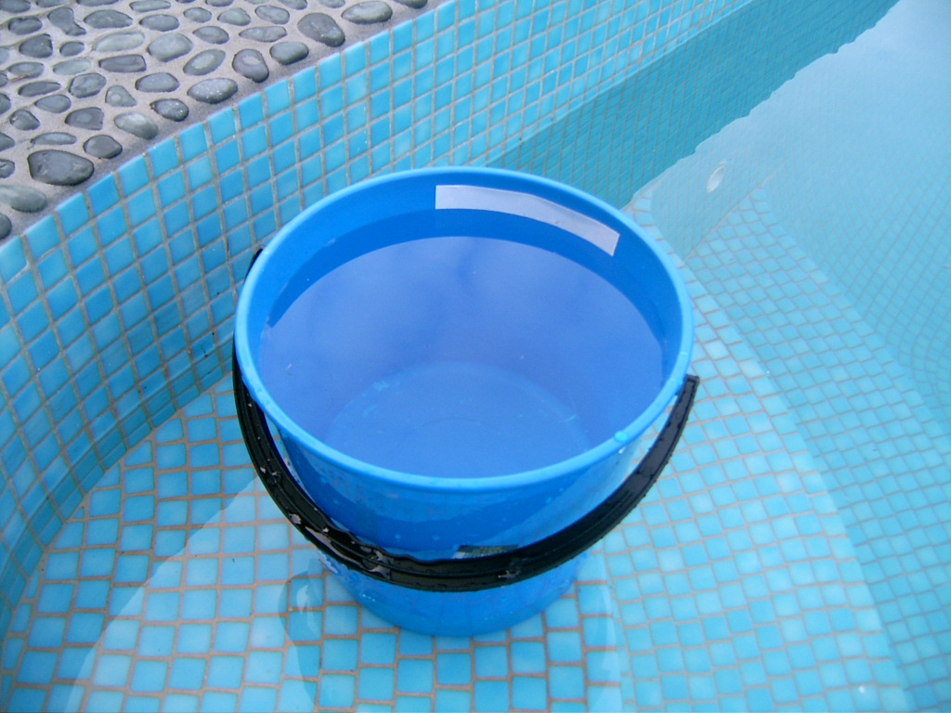
1. Before starting the test, ensure the pool is full or at the normal level otherwise it will need to be topped up.

2. Fill a bucket with pool water and mark the level in the bucket with a marker or tape then place the bucket on the first step of the pool or right beside the pool.

3. Mark the level of the water in the pool with a marker or tape. This is best done inside the skimmer box.
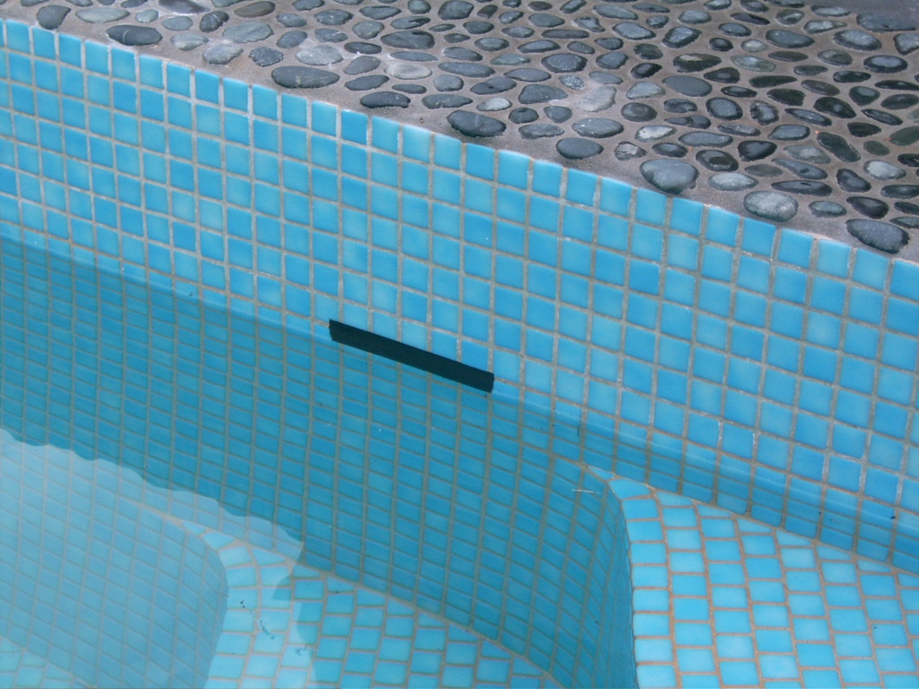

4. After the 12 hr period, record the results or drop in levels by measuring the distance from the original marks to where the level of water exists after the 12 hours.

TEST RESULTS
NO LEAK IN POOL
POOL HAS A LEAK

Evaporation Water loss
Rate Rate

BUCKET POOL
POOL BUCKET

So, if your initial evaporation test shows you do have a leak in your pool, CALL LEAKINC NOW and we will provide further helpful information regarding our leak source tests to help solve your leak problems.

